Video 1 - Introduction to Power BI
Topics
- Welcome to Power BI Playlist
- Why learn Power BI?
- Why we choose Power BI instead of Excel, Tableau and Python?
- Complete Data Analyst Workflow
- What is Business Intelligence (BI)?
- Power BI Components
- Power BI Architecture
- Power BI Desktop
- Power BI Service
- Power BI Mobile
- Power BI Report Server
- Install Power BI Desktop
- Interface Overview
Why we learn Power BI?
Power BI is a Business Intelligence (BI) and Data Visualization tool developed by Microsoft that helps users connect to multiple data sources, transform data, analyze it, and create interactive dashboards and reports for better business decision-making.
- How much did we sell today?
- Which product generated the highest revenue?
- Which city has the most customers?
- Which category is performing poorly?
- How much profit did we make this month?

Why we choose Power BI instead of Excel, Tableau and Python?
Power BI is chosen because it provides an all-in-one solution for data connectivity, data transformation, data modeling, visualization, dashboard sharing, and automatic refresh, making it one of the most practical Business Intelligence tools for organizations.

Complete Data Analyst Workflow :-
A Data Analyst Workflow is the step-by-step process of collecting, cleaning, analyzing, visualizing, and sharing data to help businesses make informed decisions.

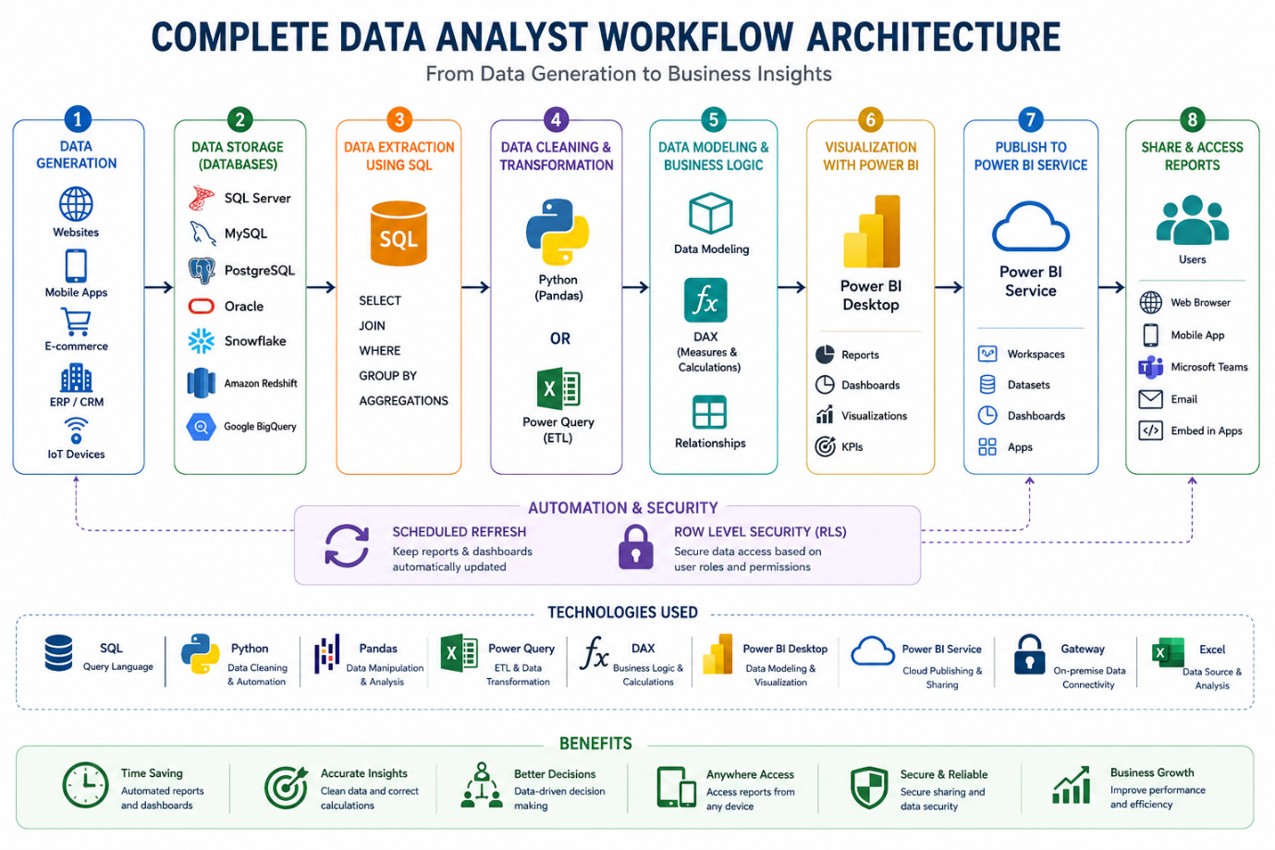

What is Business Intelligence (BI)?
Business Intelligence is the process of converting raw data into meaningful information that helps businesses make better decisions.

Power BI Components :-

Power BI Components are the different products and services that work together to collect, analyze, visualize, publish, and share business data.
The main Power BI components are:
- Power BI Desktop
- Power BI Service
- Power BI Mobile
- Power BI Report Server
- On-premises Data Gateway

Power BI Architecture :-
Power BI Architecture is the complete flow of data from different data sources to Power BI reports and finally to business users.
Data Sources
↓
Power BI Desktop
↓
Power Query
↓
Data Model
↓
DAX
↓
Reports
↓
Publish to Power BI Service
↓
Managers / Clients / Mobile Users

Power BI Desktop :-

Power BI Desktop is a free Windows application used to connect data, clean data, build data models, write DAX formulas, and create interactive reports and dashboards.

Power BI Service :-

Power BI Service is Microsoft's cloud platform used to publish, share, manage, collaborate, and refresh Power BI reports and dashboards online.

Power BI Mobile :-

Power BI Mobile is the mobile application that allows users to access and interact with Power BI dashboards and reports from smartphones and tablets.

Power BI Report Server :-

Power BI Report Server is an on-premises solution that allows organizations to host, manage, and share Power BI reports within their own infrastructure instead of using the Power BI cloud service.

On – premises Gateway :-

Securely connect on-premises data sources to the Power BI Service for scheduled refresh.

Installing Power BI :-

Power BI Overview :-

